Difference In Travel Fares

City Safari
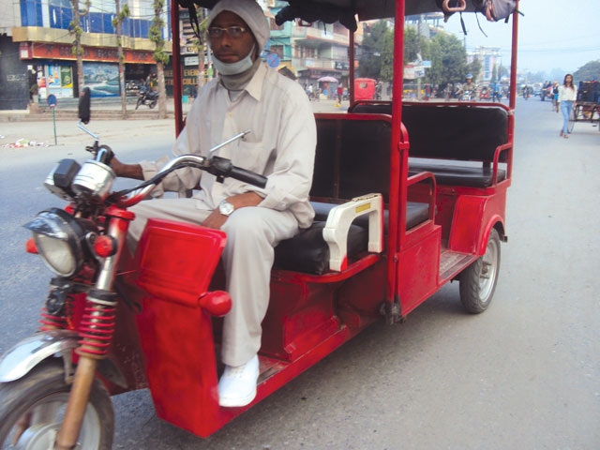

PROBLEMS:

One of the most common medium of Transportation is City Safari in Terai region. There's a lot of problem in transportation system in Nepal and the main problem people are facing is difference in travel(safari)fares. There is no fixed amount for it.

people charge, accordingly to the distance and the person(outsider and local). Even the local are sometime asked to pay more than the normal fair. While the outsider are certainly asked for amount money, and they don't have any idea about the normal fair. And safari aren't available everywhere, in the city you have to reach a certain chowk to find it.

IDEATE:
I came up with the following solution

- If only we had a app, which showed the location and contact of the nearest safari and exact fair.
- Show the location using google maps.

User Persona:

- Mom: S9t
Even though its a great initiative, I feel its not applicable to all age groups. Elderly people who are still not accustomed to using smartphones won't be helped by this app. So, my suggestion is to find another alternative as well.

- Brother:
I think this is a great idea and initiative. Inconsistency in fare is one underlying problem which has been overlooked. Some safari drivers ask more money from outsiders than the normal fare. With this app, price will be more consistent

- Friend:
it seems as a good idea,as you can see the location of safari and contact them, no longer we have to go chowk and for it. And fare calculation seems fair, they cannot fool people and take more money.

Prototype:

Location Tab
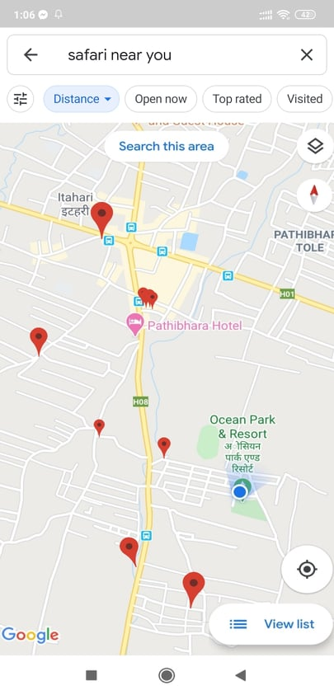

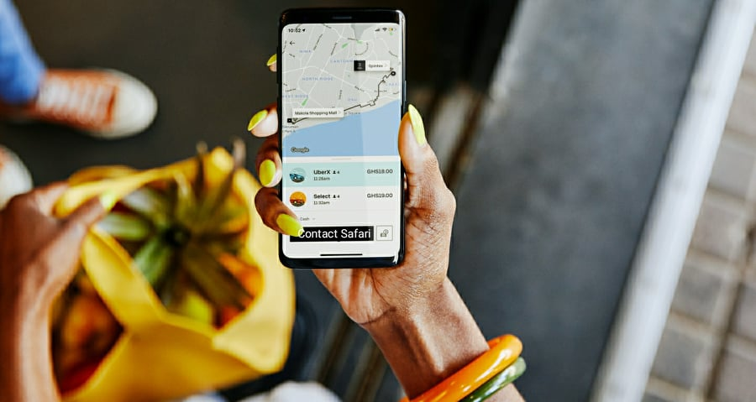

Contact Tab

Fare Calculation
